In The Kingdom of Fools
By- A.K. Ramanujan’s

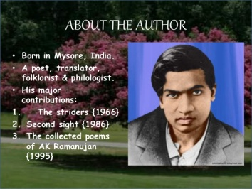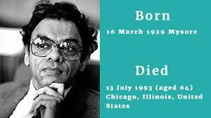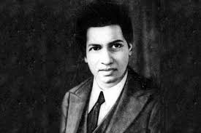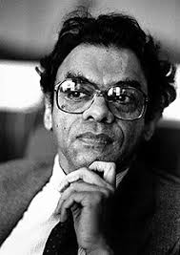

Attipate Krishnaswami Ramanujan also known as A. K. Ramanujan was an Indian poet and scholar of Indian literature who wrote in both English and Kannada. Ramanujan was a poet, scholar, a philologist, folklorist, translator, and playwright.
Born: 16 March 1929, Mysuru
Died: 13 July 1993, Chicago, Illinois, United States
Full name: Attipate Krishnaswami Ramanujan
Spouse: Molly Daniels-Ramanujan
Books: The Collected Essays of A. K. Ramanujan,
Awards: Padma Shri, MacArthur Fellowship, Sahitya Akademi Award for English Writers

Introduction:
“In the Kingdom of Fools” is a folktale that brings to light the dangers posed by foolish people. It also emphasizes the view that foolish people can be very difficult to manage. They can be dealt with only by the wise and calm people.
THEME
The story is based on the theme that foolish people are unpredictable and can be very dangerous. So, one must stay away from them even if they offer benefit for some time. The disciple got tempted by the availability of all items for one duddu each and stayed in the Kingdom of Fools in spite of warning by his wise guru. Had the guru not returned to rescue him, the disciple would have had to pay for this temptation through his life.
TITLE
“In the Kingdom of Fools” is a story about a kingdom ruled by a foolish king and his silly minister. The people too are foolish, for they obey the most ridiculous orders passed by their king. The entire action of the story takes place in this kingdom. The reasons that make this place a Kingdom of Fools are well exemplified by the episodes in which innocent people are caught one after the other in the name of justice. Hence, the title stands justified and apt in every way.
MESSAGE
The story is a folktale and gives two messages. The first message is that one should stay away from foolish people; else one is bound to suffer. The second message is that in order to tackle foolish people one should employ wisdom and not logic. The guru does not argue or reason the innocence of his disciple. Rather he flatters the king and manages to convince him that the new stake was lucky. He not only saves the life of his disciple but also rids the kingdom of the foolish king and his silly minister. In addition, he becomes the next king and his disciple the next minister.
DETAILED SUMMARY OF THE STORY
There was once a Kingdom of Fools. In this kingdom, both the king and the minister were idiots. They wanted to rule in a way different from other kings. They ordered that everyone should be awake at night and work during the day. One day a guru and his disciple arrived in the city. It was broad daylight and everyone d everyone was asleep. As soon as the sunset, the whole town woke up and started its business. The two men were hungry. They went to buy some groceries. They found that everything cost the same — a single duddu. When they had cooked and eaten, the guru realised that it would not be wise to stay in a kingdom of fools. But the disciple didn’t want to leave the place because everything was cheap there. So the guru left the place and the disciple stayed on, He ate his fill every day and grew fat. One day a thief broke into a rich merchant’s house by making a hole in the wall. As he was carrying out his loot, the wall of the house collapsed on his head and he died instantly. The thief’s brother went running to the king and complained that the merchant should be punished for not building a strong wall. The king sent for the merchant. But the merchant pleaded that it was really the fault of the man who built the wall. The bricklayer was brought in. He said that when he was building the wall, his eyes and mind were distracted towards a dancing girl. She was going up and down that street all day with her anklets jingling. The dancing girl was brought to the court. She gave the excuse that she had given some gold to the goldsmith to make some jewellery for her. The goldsmith was a lazy fellow. He delayed the work. He made her walk up and down his house a dozen times. When the goldsmith was brought before the king, he said that he had to attend to a rich merchant’s orders first. There was a wedding at the merchant’s house and he was not ready to wait. That was why he made the dancer come many times to his door. The king asked him the rich merchant’s name. He was none other than the merchant whose wall had fallen. But the merchant cried that it was not he but his deceased father who had entrusted the jeweller with the job of making the ornaments. At this, the king remarked that it was proper to punish him in place of his father. A new stake was ordered to be made ready for the execution. It occurred to the minister that the rich merchant was too thin to be properly executed on the stake. He discussed this with the king. It was decided that a fat man should be found to fit the stake. The eyes of the servants fell on the disciple who had fattened himself for months on bananas and rice and wheat and ghee. He was taken to the king. The disciple pleaded that he was innocent but it was all in vain. While he was waiting for his death, he remembered his guru. The guru saw everything by his magical powers. He arrived there at once to save his disciple. He whispered something in his disciple’s ear. Then he requested the king to put him to the stake first. When the disciple heard this, he said that he was brought there first and so be should be put to death first. The king was puzzled by their behaviour. He asked why each of them wanted to die first. The guru hesitatingly told him that whoever died on the stake first, would be reborn as the king of that country. The one who died next ‘4 would be the future minister of that country. The king did not want to lose the kingdom to someone else in the next round of life. He and his minister decided to go on the stake themselves and be reborn asking /1 and minister. The king told the executioners to put to death the first man who came to them and then do the same to the second man. That night the king and his minister went secretly to the prison and released the guru and the disciple. They then disguised themselves as the two and got themselves executed. The people now begged the guru t and the disciple to be their king and minister. The two agreed and changed all the old laws. From then onwards, the night was to be night and day was to be the day. Also, nothing A could be got for a duddu. The place became like any other place.
CHARACTERS
The Guru
The guru was a very wise man who never succumbed to any temptation. He was quick to judge that his disciple and he were in the Kingdom of Fools. Knowing that the behaviour of foolish people is unpredictable, he decided to leave the city immediately. He did not get tempted like his disciple did by the one duddu price for everything in that kingdom. He also knew that a foolish person should be tackled wisely. He did not try to reason with the king regarding the innocence of his disciple. Instead, he flattered the king with false praise and obtained the freedom of both his disciple and the kingdom. He earns readers’ appreciation for his intelligence and presence of mind.
The Disciple
The disciple was a simple but greedy fellow. He followed his guru everywhere and listened to him. However, once he could not resist the temptation of good and cheap food available in the Kingdom of Fools. He did not pay heed to his guru’s warning and stayed back. His greed almost cost him his life but he quickly regained sense. He had faith in his guru’s powers; that is why he first recalled him in his thoughts and then behaved according to the plan devised by him. This character also brings a smile to the reader by the manner in which he grows fat after eating bananas, rice, wheat and ghee.
The King
The king was a fool who owned a beautiful kingdom. He could go to any length in order to be different from others. His orders were foolish and his ideas stupid. Turning day into night and ordering execution of those who disobeyed are examples of his silliness. The king had no idea about justice. Assuring the thief’s brother that justice would be done and terming the thief’s death as murder indicate his lack of knowledge about justice. The king did not have any sound sense of judgment about people either. He could not see that the guru was flattering him to rescue his disciple. His gullible disposition led him to believe every word uttered by the guru and ended up getting executed by his own men.
The Minister
The King’s foolishness was rivaled only by his minister who was equal. Partner in the foolish orders passed by the king. The king consulted him on different matters but the minister could never give any sane advice. He would be as irrational as the king himself. It was the minister’s idea to find a fat man who fitted the stake so that the order of execution could be put through. The killing of the minister does not rouse any sympathy for he was a dumb character who was responsible for his own death.

